
CONFIDENTIAL CS/NOV 2026/CSC429

UNIVERSITI TEKNOLOGI MARA FINAL EXAMINATION

COURSE
COURSE CODE
EXAMINATION TIME
COMPUTER ORGANIZATION AND ARCHITECTURE

CSC429
NOVEMBER 2026
3 HOURS

INSTRUCTIONS TO CANDIDATES

- This question paper consists of two (2) parts: PART A (10 Questions) PART B (1 Question)

- Answer ALL questions in the Answer Booklet. Start each answer on a new page.

- Do not bring any material into the examination room unless permission is given by the invigilator .
- Please check to make sure that this examination pack consists of: i) the Question Paper
  - an Answer Booklet - provided by the Faculty

- Answer ALL questions in English.

DO NOT TURN THIS PAGE UNTIL YOU ARE TOLD TO DO SO

This examination paper consists of 7 printed pages.

PART A (80 MARKS)
Answer ALL questions in this part.
QUESTION 1 (5 marks)
- List THREE (3) characteristics of Symmetric Multiprocessor (SMP).
- Describe ONE (1) advantage of Symmetric Multiprocessor (SMP) interms of availability.
QUESTION 2 (5 marks)
- The Von Neumann Architecture was first introduced inwhich computer generation?
- Draw the Von Neumann Architecture.
- Central Processing Unit (CPU) is one of the components of a Von Neumann Architecture
whereas Control Unit and Arithmetic Logic Unit are the main components of a CPU. What
is the main task of a CU?
QUESTION 3 (5 marks)
Question 1 is based on the following image and statements in Figure 1.
Charles Babbage was an English
mathematician, a philosopher and also an
inventor. He was born on 1791 in London
England. He was known for his
contributions to invent machine X to solve
four basic arithmetic functions. The
machine X has improved its calculations
design from Stepped Reckoner machine
and early mechanical calculator. The
machine X has introduced a number of
computing concepts which are still in use
today. Although this machine was not
actually completed, it is the first machine
that deserved to be called as a computer.
- What is the machine X name?
- In which generation does the machine X introduced?
- What is the function of machine X?
- Name the machine that has been invented prior to machine X?
- What is the title given to Charles Babbage due to his success to invent machine X?
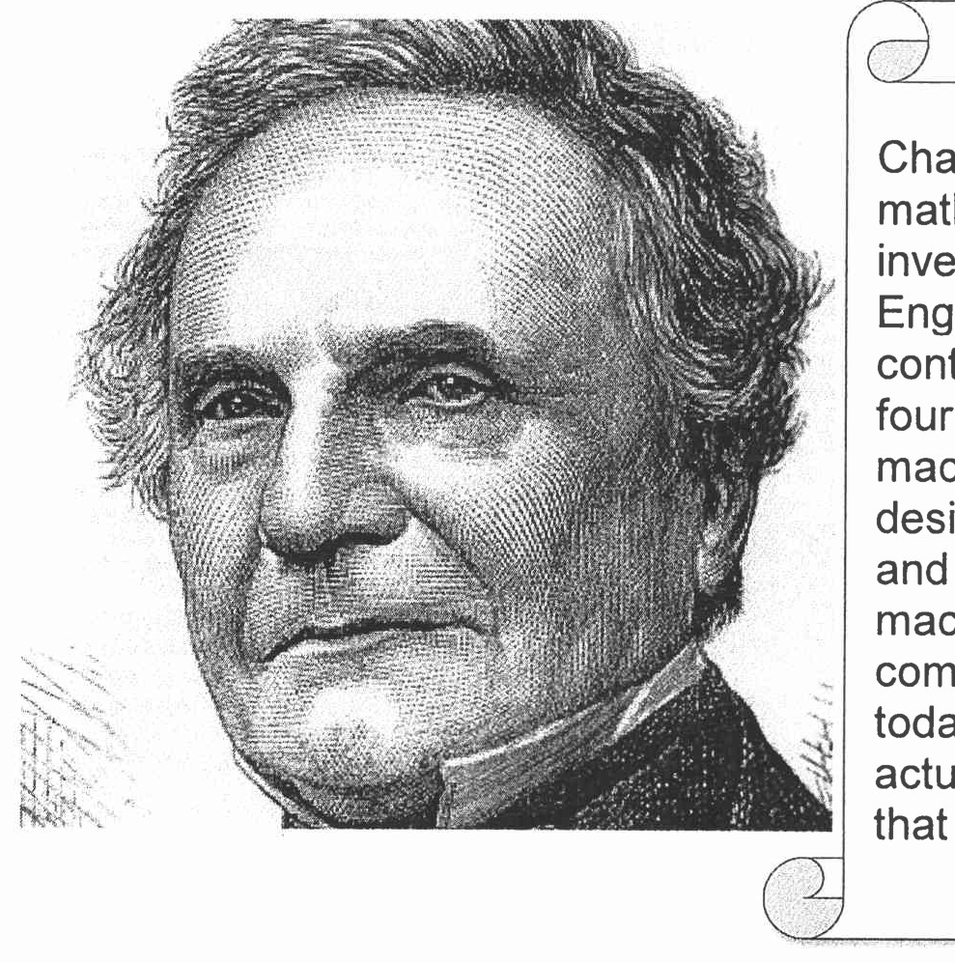
Figure 1 : A snippet from biography web page
QUESTION 4 (5 marks)
Solve the following equation of -56s + A3H using 1's and 2's complement method. Show your
complete workflow.
QUESTION 5 (10 marks)
- Differentiate the involvement of CPU in the interrupt-driven I/O technique and Direct
Manipulation Access
- Define interrupt.
- Discuss what happens during a context switch.
- Elaborate on the benefit of a context switch.
QUESTION 6 (10 marks)
Replacement algorithm is used to determine which entry in a cache to flush to main
memory when it is desired to cache a new block of data.
- Which mapping function does not need to have a replacement algorithm?
- Describe FOUR (4) types of replacement algorithm.
QUESTION 7 (10 marks)
- Convert -156.1562510 to a floating-point number in IEEE single precision format in
hexadecimal value form. Show your workflow.
- Convert BD40 0000H in IEEE single precision floating point number to decimal value form.
Show your workflow.
QUESTION 8 (10 marks)
Input output technique can be segregated into programmed, interrupt-driven and direct
memory access (DMA).
- What is DMA?
- How can the DMA technique improve the overall computer performance?
- Discuss TWO (2) major drawbacks of programmed and interrupt-driven input output
technique that inspire hardware developer to introduce DMA.
- Conventional access is depicted in Figure 2. Redraw Figure 2 to illustrate DMA
architecture.
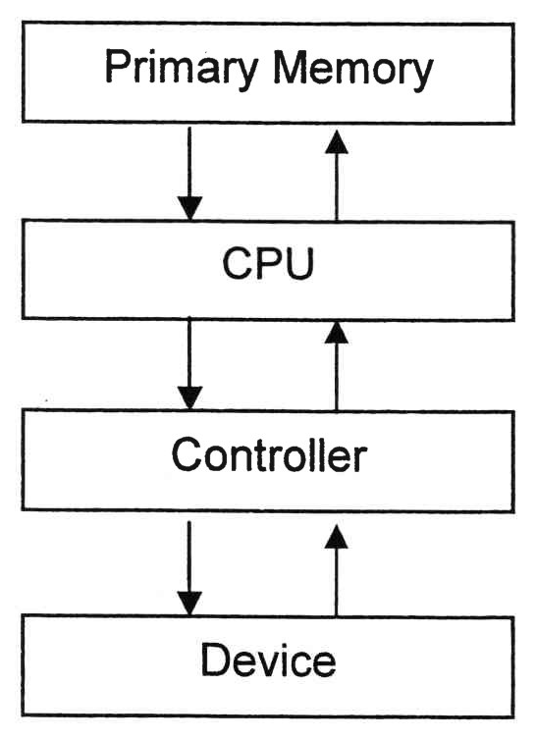
Figure 2: Conventional access architecture
QUESTION 9 (10 marks)
- Differentiate between organization and architecture.
- Explain the function of THREE (3) Central Processing Unit (CPU) components.
QUESTION 10 (10 marks)
Question 7 is based on the following scenarios.
While cleaning his house, Ahmad found an old cassette tape of a popular 80's band. He
played the tape and listened to several songs according to the listed tracks.
Hafiz was tasked to research on the history of Malay culture by his professor. He went
to the National Archive to search for information and manage to access one the
resources which was stored in a floppy disk.
Sara is planning to buy a new computer. She aims to get one with good processing
speed. While researching for computer specifications, she found out that larger cache
space has a direct effect towards processing performance.
Hana loves playing role-playing games (RPG) and is planning to buy a newly released
game that requires a high-speed RAM. But, she is devastated when she found out that
her game console does not support the minimum RAM requirement of the game.
- Based on the above scenarios, identify the access method for each storage
devices/memory mentioned in (i), (ii), (iii) and (iv).
- Describe SRAM and DRAM.
- Which level of cache is the fastest in a three-level cache architecture? Which type of
RAM is used to implement the cache?

PART B (20 MARKS)
Answer the question in this part.
QUESTION 11 (20 marks)
Question 1 is based on Figure 3 and Table 1.
Write the appropriate programs using correct assembly language notations and comments to
compute the equation represented in Figure 3 using zero-, one-, and three-address
instructions. The instructions available for use are provided in Table 1. Note that Register A,
B, C, and D cannot be modified, and Register x, y, and z can be used as temporary registers,
However, the final answer must be stored in Register y.
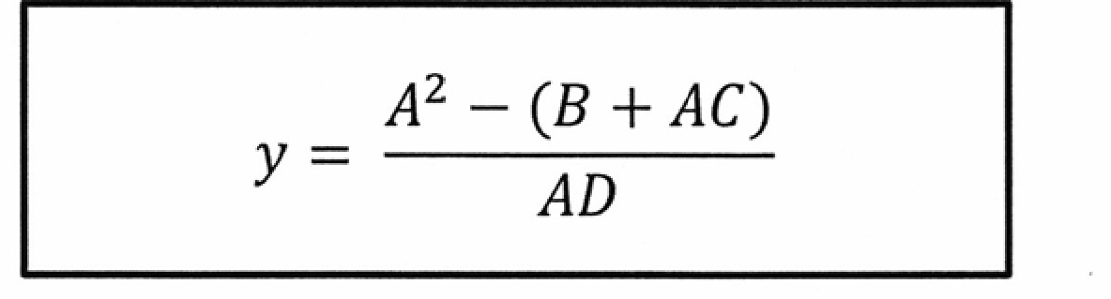
Figure 3
Table 1: Machine Instruction
Zero-address | One-address | Three-address
PUSH | LOAD | ADD
pop | STOR | SUB
ADD | ADD | MUL
SUB | SUB | DIV
MUL
DIV | DIV

